Current Operable Unit 1 – SLKB Remedial Progress for Week Ending 3/12/10
Creamer Environmental Inc., National Grid’s Remediation Contractor, has mobilized to the former Summers Lumber /King Bear property (SLKB). The mobilization includes bringing construction equipment, materials, and temporary facilities to the site. Creamer has also installed security fence around the perimeter of the work area. Excavation has commenced this week as well as minimal transportation of impacted soil off site. To date, 12 trucks have transported approximately 300 tons (200 cubic yards) of soil to Bay Shore Soil Management (formerly ESMI of NJ) for thermal desorption.
GEI, National Grid’s Remediation Oversight Consultant, continues to perform CAMP (Community Air Monitoring Program), which will continue throughout the project.

Two-Week Outlook
Creamer Environmental Inc. will complete mobilization of equipment, materials, and temporary facilities to the site. The excavation and backfill tasks will continue approximately into the first or second week in April. Additionally, loading and transportation of impacted soils will continue and steadily increase as the project progresses.
General hours of operation will continue to be Monday through Friday, 7:00 AM to 3:30 PM. However, work hours will be extended when necessary to maintain schedule or to complete critical tasks.

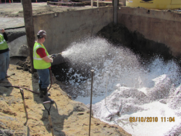
Applying odor control foam to the excavation
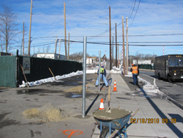
Installing new security fence

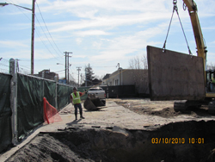

Installing American Shore Slide Rail trench boxes

